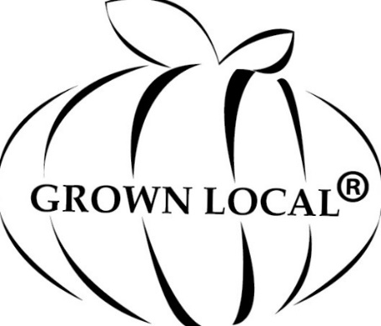
Grown Local Global LLC
Email: www.grownlocalglobal@gmail.com
Website: www.grownlocalglobal.org
Phone: 360-303-3711
Certified Grown Local Application
Food Producers, Food Processors, Food Distribution are Eligible to be Certified Grown Local.
Legal Name:
Business Name & UBI#:
Mailing Address:
Business Address if different:
City, State, Zip:

Business Operation: Please describe your grower/producer and/or processor operation.

List your markets where you sell your products. Include physical locations for farmers markets, grocery stores, food coops, CSA’s, farm stands, website sales, distribution trucks, charter boats, planes, or other.
Please attach supporting documents to show proof of annual income: Current IRS Tax Return, 3-current sales invoices, or sales records.
Payment Due is based on Gross Annual Income:
$100k or less: $175 annual dues.
$101k -$500k: $350 annual dues.
$501k -$1mil: $700 annual dues.
$1.1mil -$10mil: $1400 annual dues.
$10.1mil more: $2800 annual dues.

